DATA SPLITTING

AIM:
To split a student dataset into 80% training data and 20% testing data using the train_test_split() function in Python.
ALGORITHM:
- Import the Pandas library and train_test_split from Scikit-learn.
- Load the dataset from the data.csv file.
- Select Hours_Studied, Attendance, and Assignments as input features (X).
- Select Result as the target variable (y).
- Split the dataset into 80% training data and 20% testing data.
- Set random_state=42 to ensure reproducible results.
- Display the training and testing datasets.
- Print the number of training and testing samples.
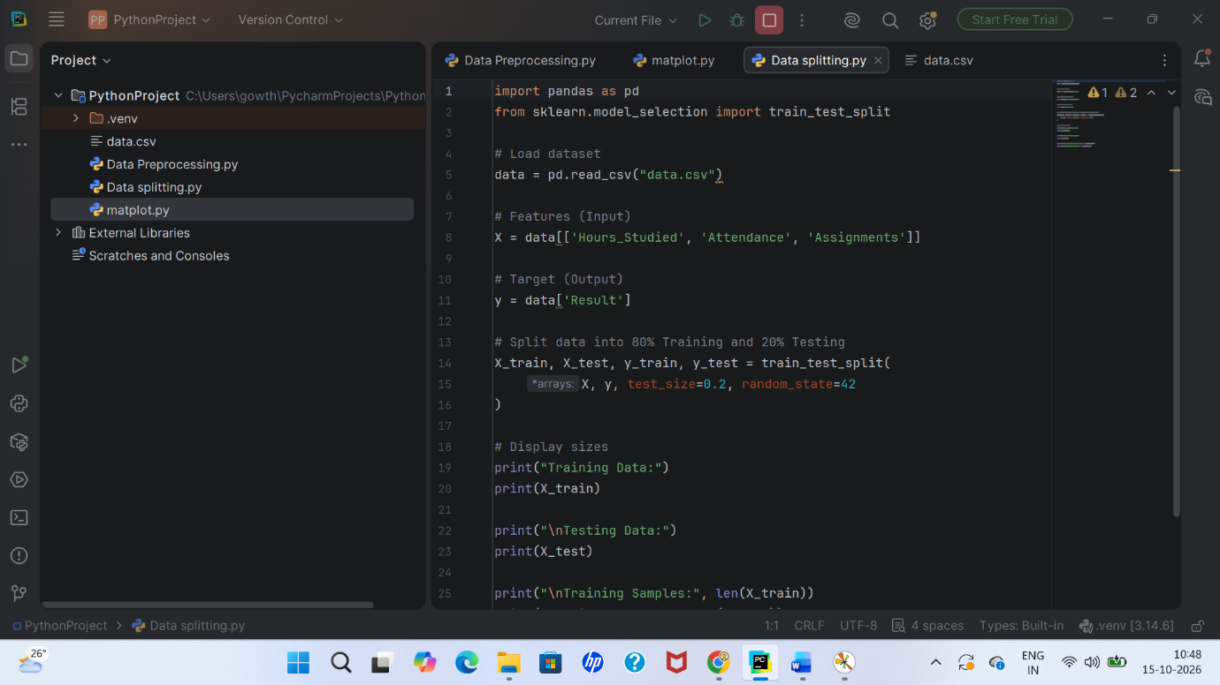
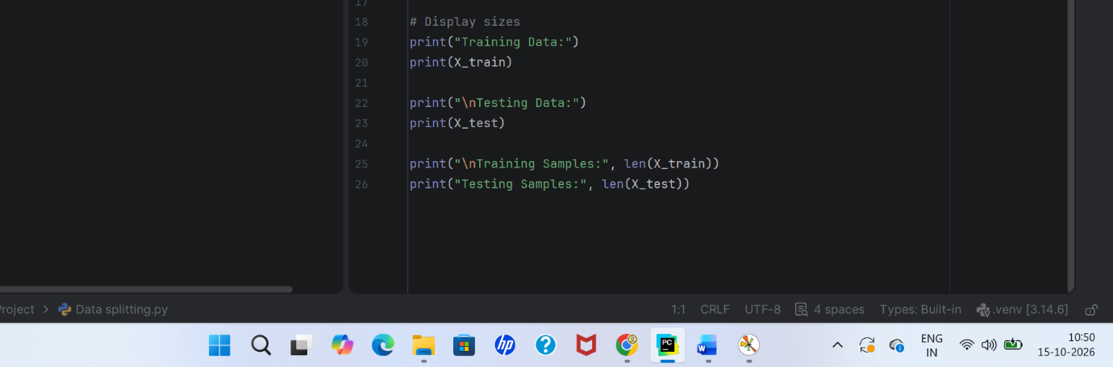
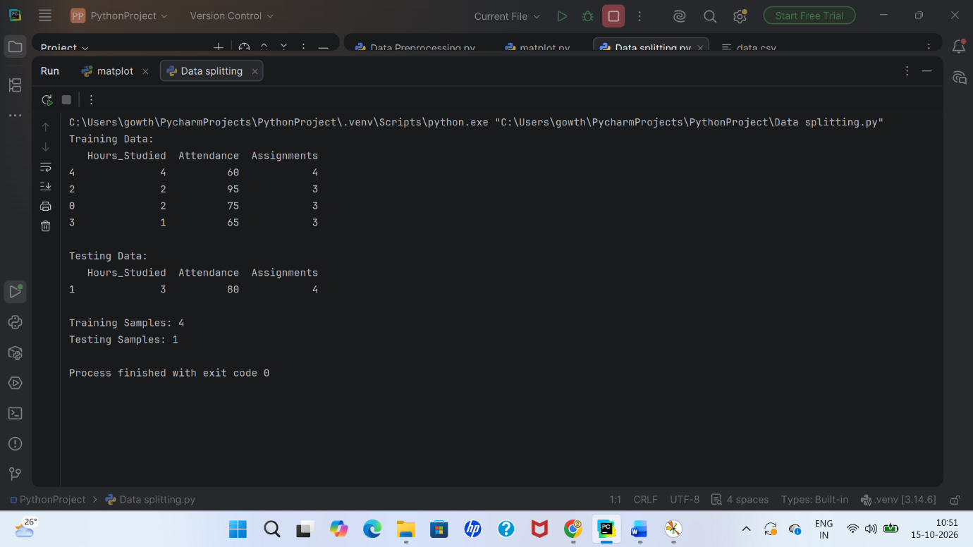

RESULT:
Thus, the student dataset was successfully divided into 80% training data and 20% testing data, and the datasets with their sample counts were displayed.

